Parallel Line Segments
# Source: AI Source: Provided by: [Data Path: Persons Table -> ID Column: 1, Name_En Column: Motasem Essam] -> From: [ChatGPT] on [7/25/2026]
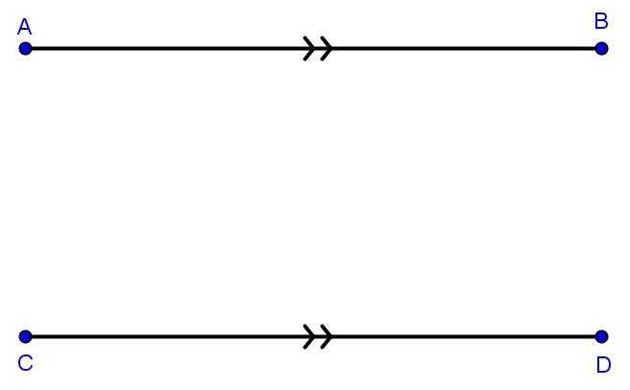
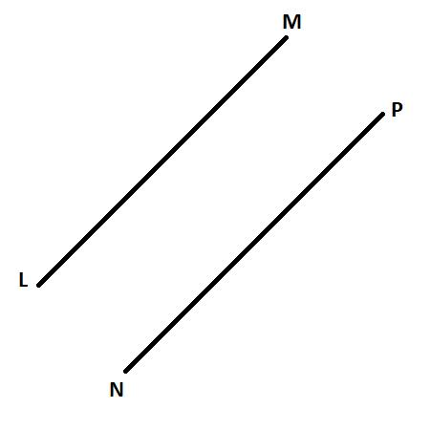
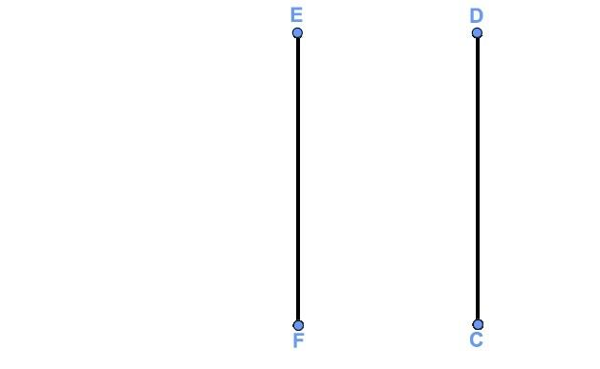
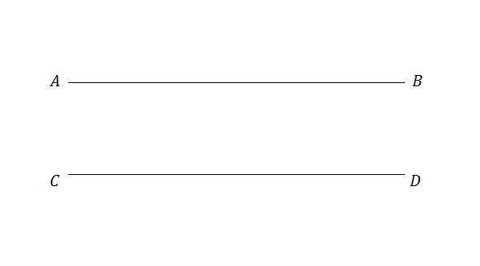
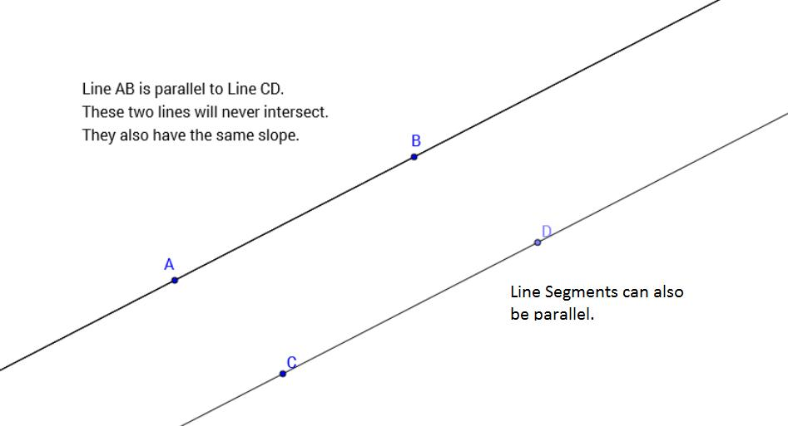

Definition
# Source: AI Source: Provided by: [Data Path: Persons Table -> ID Column: 1, Name_En Column: Motasem Essam] -> From: [ChatGPT] on [7/25/2026]
Parallel Line Segments are two or more finite line segments that lie on parallel lines and never intersect, even if they are extended into full lines. They maintain the same perpendicular distance from each other throughout their lengths.
Unlike parallel lines, parallel line segments have finite lengths and two endpoints.

Characteristics
# Source: AI Source: Provided by: [Data Path: Persons Table -> ID Column: 1, Name_En Column: Motasem Essam] -> From: [ChatGPT] on [7/25/2026]
Parallel line segments:
- Have two endpoints each.
- Have finite lengths.
- Never intersect.
- Maintain a constant distance apart.
- Have the same direction.
- May have equal or different lengths.

Illustration
# Source: AI Source: Provided by: [Data Path: Persons Table -> ID Column: 1, Name_En Column: Motasem Essam] -> From: [ChatGPT] on [7/25/2026]
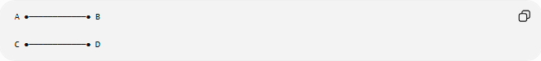
A ●────────────● B

C ●────────────● D
The two horizontal segments are parallel.

Mathematical Representation
# Source: AI Source: Provided by: [Data Path: Persons Table -> ID Column: 1, Name_En Column: Motasem Essam] -> From: [ChatGPT] on [7/25/2026]
Parallel line segments are represented using the parallel symbol:
$$\overset{‾}{AB}∥\overset{‾}{CD}$$

Coordinate Geometry
# Source: AI Source: Provided by: [Data Path: Persons Table -> ID Column: 1, Name_En Column: Motasem Essam] -> From: [ChatGPT] on [7/25/2026]
Horizontal Parallel Segments
Segment 1:
$$A\left(1 , 2\right), B\left(6 , 2\right)$$
Segment 2:
$$C\left(1 , 5\right), D\left(6 , 5\right)$$
Both have:
- Slope:
$$m=0$$
Therefore,
$$\overset{‾}{AB}∥\overset{‾}{CD}$$

Oblique Parallel Segments
Segment 1:
$$A\left(1 , 1\right), B\left(5 , 5\right)$$
Slope:
$$m=\frac{5-1}{5-1}=1$$
Segment 2:
$$C\left(2 , 6\right), D\left(6 , 10\right)$$
Slope:
$$m=\frac{10-6}{6-2}=1$$
Since
$$m_{1}=m_{2}$$
the segments are parallel.

Vertical Parallel Segments
Segment 1:
$$A\left(3 , 1\right), B\left(3 , 6\right)$$
Segment 2:
$$C\left(7 , 2\right), D\left(7 , 8\right)$$
Both have the same constant x-coordinate within each segment and are parallel.

Properties
# Source: AI Source: Provided by: [Data Path: Persons Table -> ID Column: 1, Name_En Column: Motasem Essam] -> From: [ChatGPT] on [7/25/2026]
Parallel line segments:
- Never intersect.
- Have the same direction.
- Maintain a constant perpendicular distance.
- May have different lengths.
- Have equal slopes (except vertical segments, whose slopes are undefined).

Examples
# Source: AI Source: Provided by: [Data Path: Persons Table -> ID Column: 1, Name_En Column: Motasem Essam] -> From: [ChatGPT] on [7/25/2026]
Examples of parallel line segments include:
- Opposite sides of a rectangle.
- Opposite sides of a parallelogram.
- Railway sleepers (idealized).
- Parallel beams in a bridge.
- Parallel edges of a window frame.

Applications
# Source: AI Source: Provided by: [Data Path: Persons Table -> ID Column: 1, Name_En Column: Motasem Essam] -> From: [ChatGPT] on [7/25/2026]
Parallel line segments are used in:
- Plane Geometry
- Coordinate Geometry
- Engineering
- Architecture
- Construction
- Surveying
- CAD (Computer-Aided Design)
- Technical Drawing
- Computer Graphics
- Robotics

Advantages
# Source: AI Source: Provided by: [Data Path: Persons Table -> ID Column: 1, Name_En Column: Motasem Essam] -> From: [ChatGPT] on [7/25/2026]
Studying parallel line segments helps to:
- Construct geometric figures.
- Analyze geometric relationships.
- Design engineering structures.
- Produce accurate technical drawings.
- Model parallel structural elements.

Limitations
# Source: AI Source: Provided by: [Data Path: Persons Table -> ID Column: 1, Name_En Column: Motasem Essam] -> From: [ChatGPT] on [7/25/2026]
Parallel line segments:
- Have finite lengths.
- May have different lengths.
- Do not imply congruence.
- Exist only between their endpoints.

Comparison with Related Objects
# Source: AI Source: Provided by: [Data Path: Persons Table -> ID Column: 1, Name_En Column: Motasem Essam] -> From: [ChatGPT] on [7/25/2026]
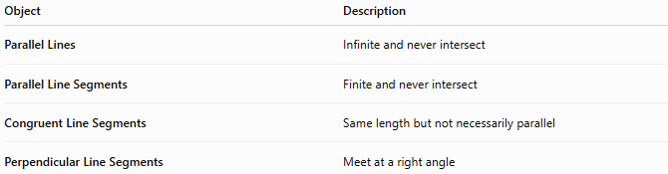
Object | Description
Parallel Lines | Infinite and never intersect
Parallel Line Segments | Finite and never intersect
Congruent Line Segments | Same length but not necessarily parallel
Perpendicular Line Segments | Meet at a right angle

Key Points
# Source: AI Source: Provided by: [Data Path: Persons Table -> ID Column: 1, Name_En Column: Motasem Essam] -> From: [ChatGPT] on [7/25/2026]
- Parallel Line Segments are finite line segments that never intersect.
- They are represented by:
$$\overset{‾}{AB}∥\overset{‾}{CD}$$
- They maintain a constant distance apart.
- They may have equal or different lengths.
- Non-vertical parallel segments have equal slopes.
- Parallel line segments are fundamental in geometry, engineering, architecture, construction, CAD, surveying, and technical drawing.

Conclusion
# Source: AI Source: Provided by: [Data Path: Persons Table -> ID Column: 1, Name_En Column: Motasem Essam] -> From: [ChatGPT] on [7/25/2026]
Parallel Line Segments are finite straight segments that lie in the same direction and remain a constant distance apart without intersecting. Although they are portions of parallel lines, their finite lengths distinguish them from infinite lines, and they may have either equal or unequal lengths. Parallel line segments are fundamental in plane geometry, coordinate geometry, engineering, architecture, construction, surveying, CAD, technical drawing, robotics, and computer graphics, where they are widely used to model opposite edges, structural members, and accurately aligned components.

